**Information Subject:** Company Production

Authors: Zach Burmeister, Cameron Hager, Paul Sanchez, Julia Tremaroli

**Requirements:**



**Dimensions:**

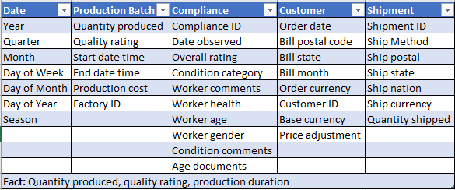

**Hierarchies/categories**